**Results**

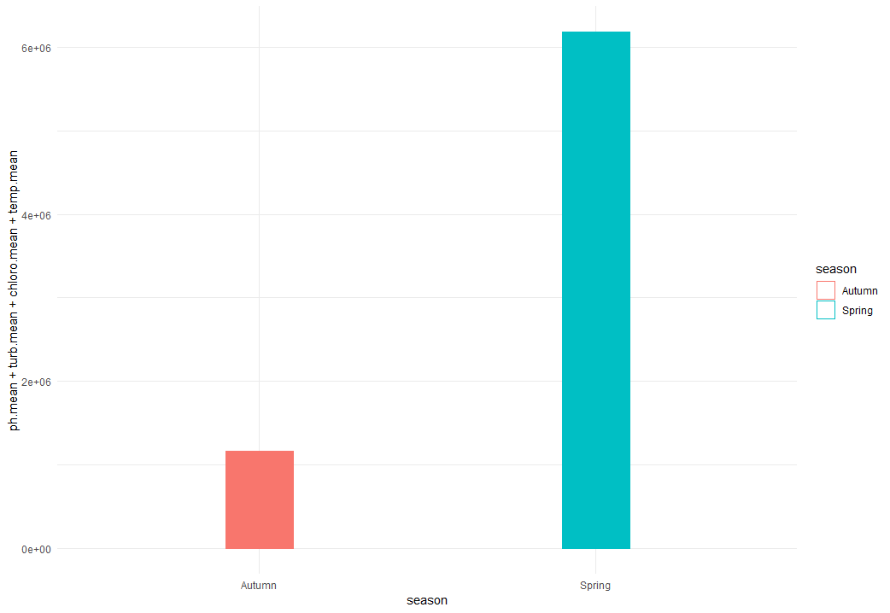

**Figure 1.** Bar graph comparing the mean average values of the four significant abiotic factors to the fall and spring seasons in Lake Erie.

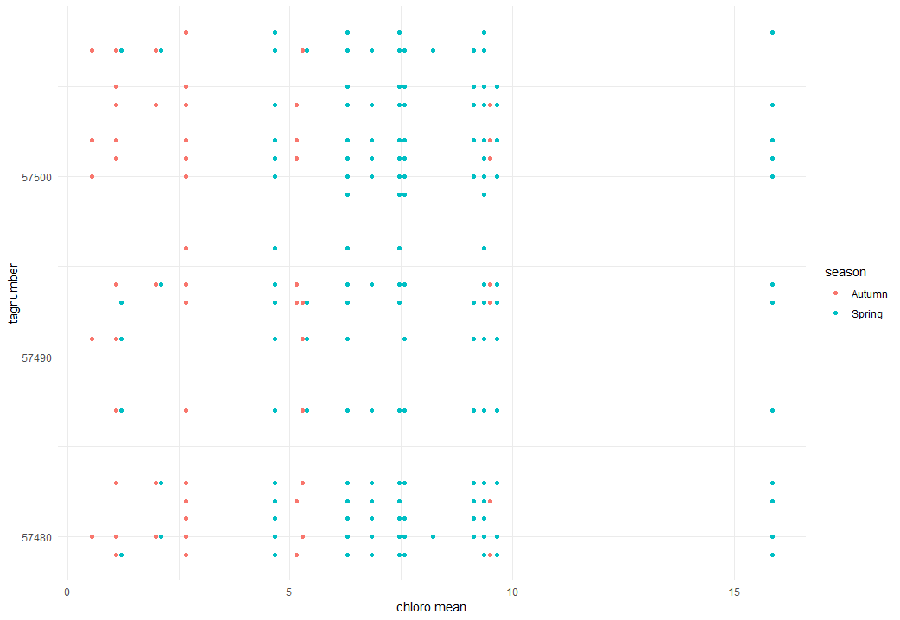

**Figure 2.** Scatterplot comparing the mean average abundance of chlorophyll (in mg) in the water to the walleye population in Lake Erie by season

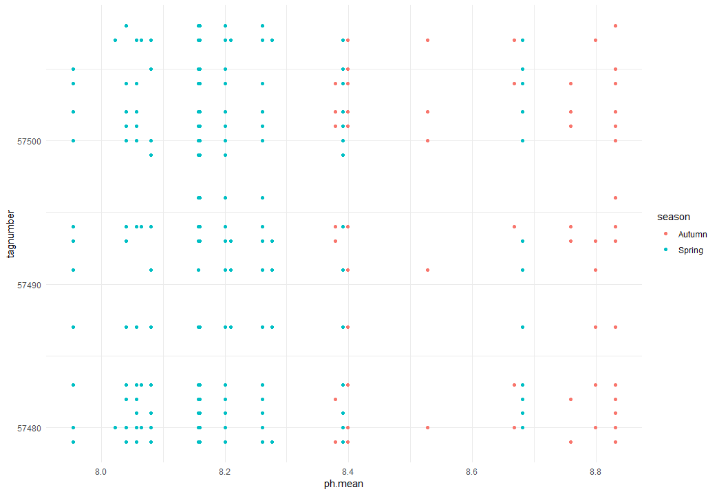

**Figure 3.** Scatterplot comparing the mean average pH value of the water to the walleye population in Lake Erie by season

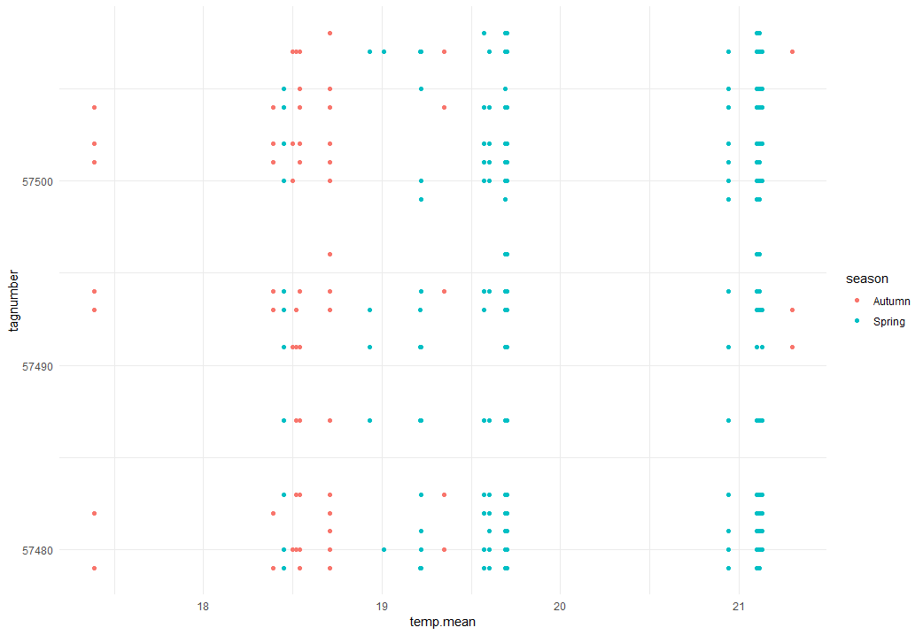

**Figure 4.** Scatterplot comparing the mean average temperature (in Celsius) of the water to the walleye population in Lake Erie by season

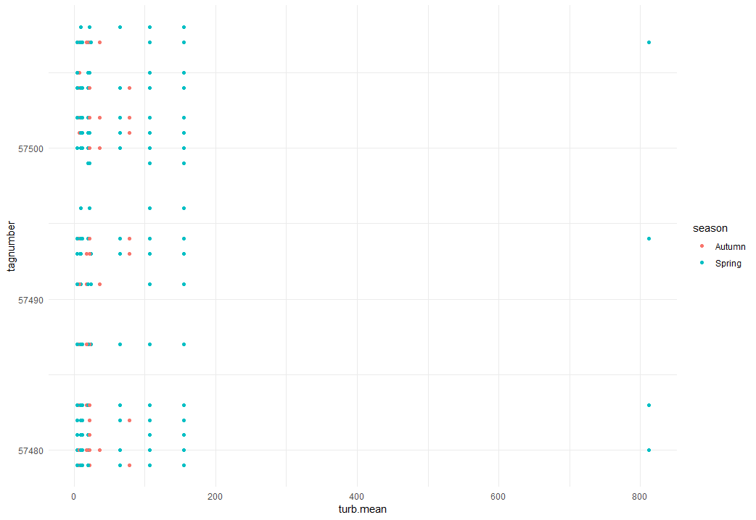

**Figure 5.** Scatterplot comparing the mean average water turbulent (in ppm) to the walleye population in Lake Erie by season

When looking at figure 1, comparing both seasons with the four strongest abiotic correlations to walleye populations and its dispersal across lake eerie, we can see that the mean abiotic averages are much stronger or more relevant in the spring than in comparison to the fall, showcasing that the walleye population and dispersal heavily depends on the season currently in effect. We can see here that in autumn the average conditions are much lower than in the spring, and since the walleye heavily benefit and rely on these four key conditions, that there is much less walleye dispersal and activity in autumn in comparison to spring. When looking at figures 2 through 5 we get a much clearer picture of the four key factors and their effect on walleye populations and dispersal based on the season the data was recorded. From all four graphs you can quickly gather that there were far more walleye datapoints recorded from the spring than the fall, showing that they are much more prevalent from the spring to summer seasons than the fall to winter seasons in Lake Erie, also signifying that the abiotic conditions are far more favorable in the springtime period than the fall. Breaking down each graph individually, from figure 2 we can see that the average amount of chloroform in the water the species can tolerate is between 5-10 mg. With a few outliers sitting at around 15mg in the water. In the fall the chloroform levels the species sits in are between 0-5 mg. With much less datapoints outside of that range for the spring. In figure 3 we can see that the species is most comfortable between averaging pH values of 8.0 to 8.4, where there is a lot more walleye activity recorded and primarily in the spring, with fewer reported between 8.4-8.8, those mostly being in the fall. In figure 4 we can see that walleye activity is highest in water temperatures that lie between 18-21 Celsius, with when the water temperature lowering in the fall to winter months being far less datapoints of walleye activity. Finally in Figure 5 we can see that water turbulence is mostly favorable in the spring, though it does not seem to change all that much in walleye preference in the fall. We can also see that the species prefers between 0 to 200 ppm turbidity, with a few outliers within the 800-ppm range, showing that the species clearly prefers water that sits between clear and very partially cloudy.

**Discussion**

Based on the results gathered, we can see that walleye populations are much more prevalent around the spring to summer stretch of the seasons, and that temperatures, water turbidity, chloroform concentrations, and pH values of the water all play a significant role in the dispersal and success of the species and its populations. Applying to the bigger picture, we can see that many other fish species are dependent on higher water temperatures to stay warm, and that lakes and streams that maintain higher temperature tend to have the most abundant fish populations due to being better spawning conditions (A. D. Nunn, I. G. Cowx, P. A. Frear, J. P. Harvey 2003) and that these conditions are key in identifying population growth. We can also see that the number of chloro-based compounds in the water can affect fish populations spawn rates and that higher concentrations that occur from pesticides runoff and mineral composition breakdown can hinder growth rate and survivability (Chisato Kataoka et. al. 2018). As for water turbidity, cloudy water helps avoid predation far more than open clear waters, especially for fish smaller in size as it helps hide their presence among bigger predators (Mark V. Abrahams, Michael G. Kattenfeld 1997). As for pH values waters that are too acidic or too basic in value will harshly hinder fish populations and their potential to reproduce (Jacob Kann, Val H Smith 1999) thus also playing a greater role in understanding what values are most critical to fish survival. With most fish either spawning in the early spring or early fall weather (Ned W. Pankhurst, Philip L Munday 2011) Understanding these abiotic conditions and how they affect fish population survival and dispersal amongst waters across the globe can greatly aid in conservation and preservation of species, both ones that are popular trophy fish and others that play key roles in freshwater ecosystems around the world.

Sources

A. D. Nunn, I. G. Cowx, P. A. Frear, J. P. Harvey. Is water temperature an adequate predictor of recruitment success in cyprinid fish populations in lowland rivers. *Freshwater Biology*. 2003; 4; 579-588.

[Is water temperature an adequate predictor of recruitment success in cyprinid fish populations in lowland rivers? - Nunn - 2003 - Freshwater Biology - Wiley Online Library](https://onlinelibrary.wiley.com/doi/full/10.1046/j.1365-2427.2003.01033.x)

C. Kataoka, Y. Kato, T. Ariyoshi, M. Takasu, T. Narazaki, S. Nagasaka, H. Tatsuta, S. Kashiwada. Comparative toxicities of silver nitrate, silver nanocolloids, and silver chloro-complexes to Japanese medaka embryos, and later effects on population growth rate. *Environmental Pollution*. 2018; 233; 1155-1163.

[Comparative toxicities of silver nitrate, silver nanocolloids, and silver chloro-complexes to Japanese medaka embryos, and later effects on population growth rate - ScienceDirect](https://www.sciencedirect.com/science/article/pii/S0269749117324958)

J. Kann, V. H Smith. Estimating the probability of exceeding elevated pH values critical to fish populations in a hypereutrophic lake. *Canadian Journal of Fisheries and Aquatic Sciences*. 1999; 56; 2262-2270

[Estimating the probability of exceeding elevated pH values critical to fish populations in a hypereutrophic lake (cdnsciencepub.com)](https://cdnsciencepub.com/doi/abs/10.1139/f99-158)

M. V. Abrahams, M. G. Kattenfeld. The role of turbidity as a constraint on predator-prey interactions in aquatic environments. *Behavioral Ecology and Socialbiology*. 1997; 40; 169-174.

[The role of turbidity as a constraint on predator-prey interactions in aquatic environments | SpringerLink](https://link.springer.com/article/10.1007/s002650050330)

N. W. Pankhurst, P. L Munday. Effects of climate change on fish reproduction and early life history stages. *Marine and Freshwater Research*. 2011; 62; 1015-1026

[CSIRO PUBLISHING | Marine and Freshwater Research](https://www.publish.csiro.au/MF/mf10269)